Nama : Wahyu Indrawan

NIM : 18090108

Kelas : 5D

Laporan Praktikum 3

1. Source Code

view-form-matakuliah.php 🡪 application\views\

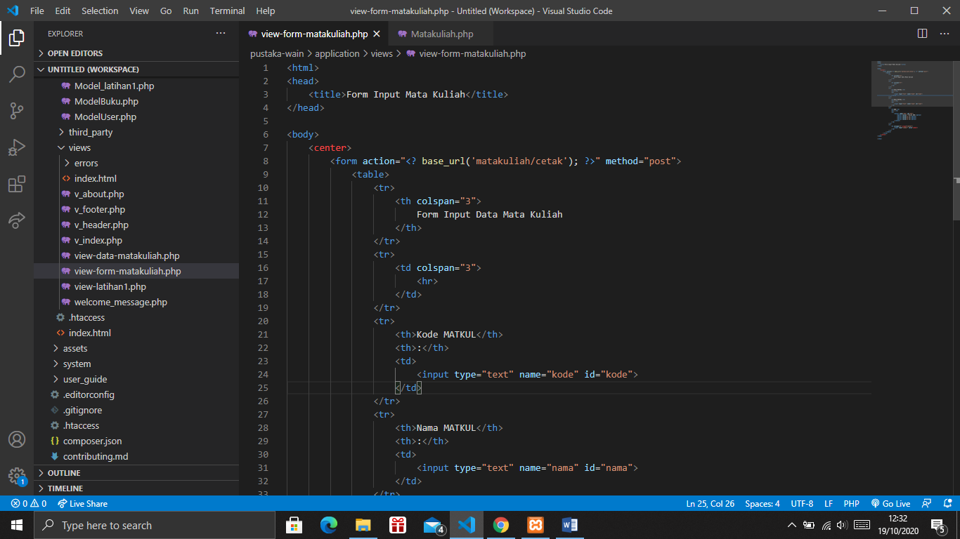

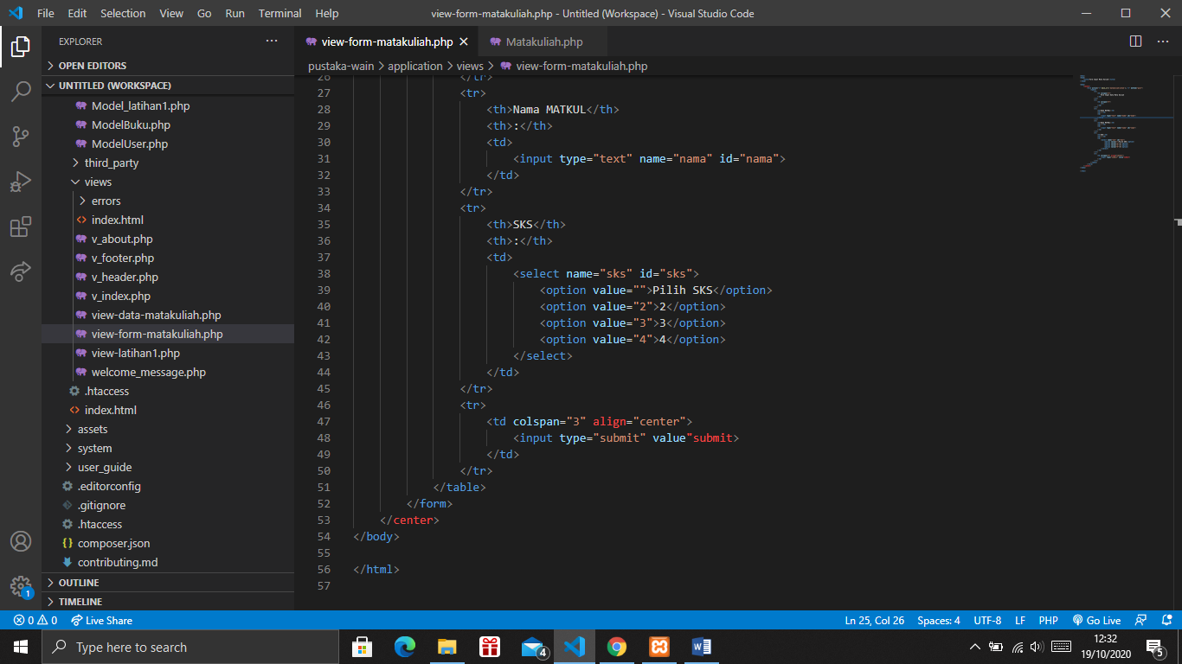

Matakuliah.php 🡪 application\controllers\

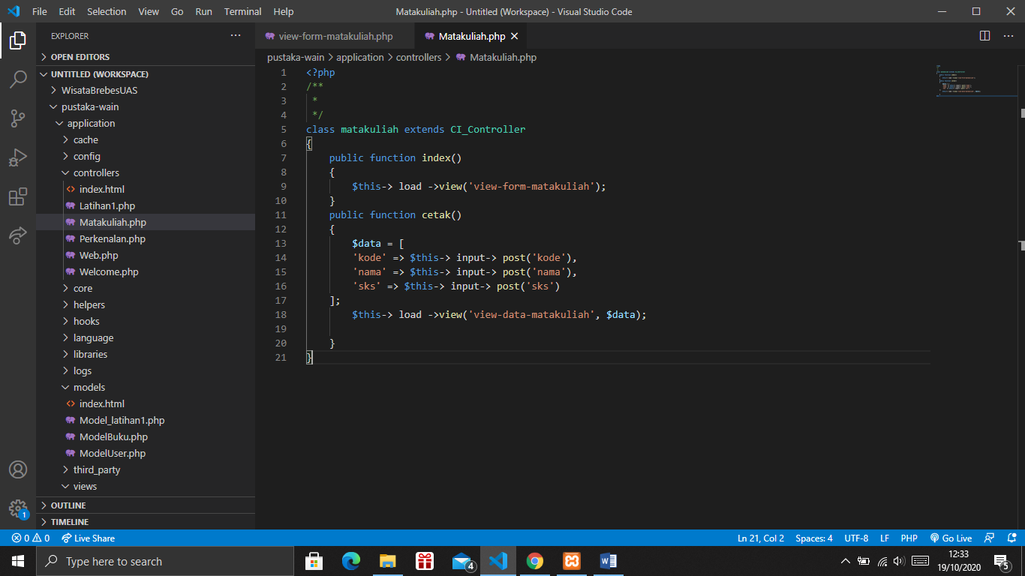

view-data-matakuliah.php 🡪 application\views\

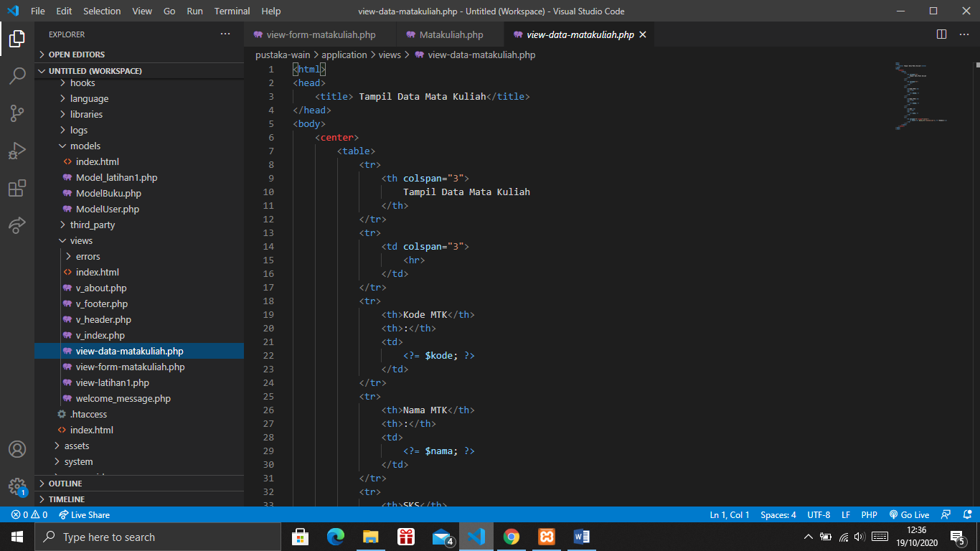

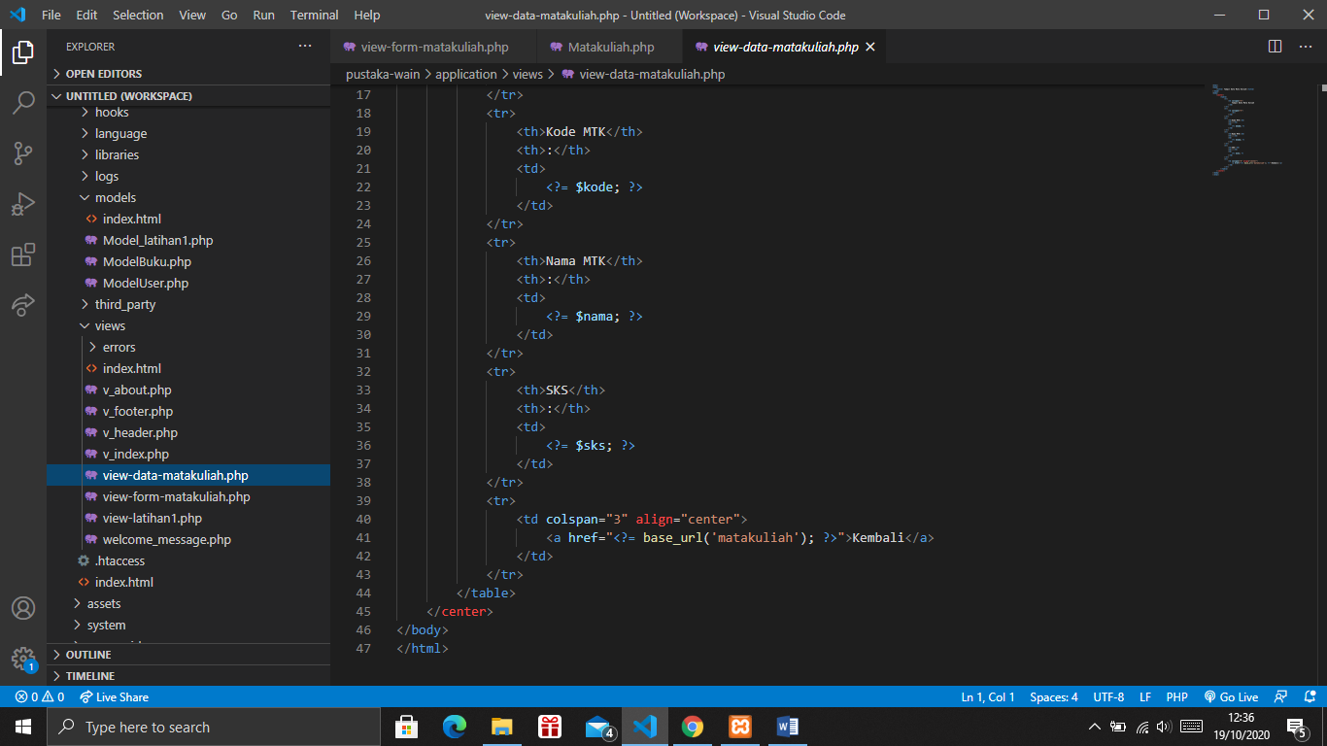

1. URL

<http://localhost/pustaka-wain/Matakuliah>

1. Capture Output Program

